**Exercise 1 Combinational circuit**

Circuit Truth Table:

|  |  |  |  |  |  |  |  |  |
| --- | --- | --- | --- | --- | --- | --- | --- | --- |
| A | B | C | D | E | F | G | H | Output |
| 0 | 0 | 0 | 0 | 1 | 1 | 1 | 0 | 1 |
| 0 | 0 | 0 | 1 | 1 | 0 | 1 | 0 | 1 |
| 0 | 0 | 1 | 0 | 0 | 1 | 1 | 0 | 1 |
| 0 | 0 | 1 | 1 | 0 | 0 | 1 | 0 | 1 |
| 0 | 1 | 0 | 0 | 1 | 1 | 0 | 0 | 1 |
| 0 | 1 | 0 | 1 | 1 | 0 | 0 | 1 | 1 |
| 0 | 1 | 1 | 0 | 0 | 1 | 1 | 0 | 1 |
| 0 | 1 | 1 | 1 | 0 | 0 | 1 | 0 | 1 |
| 1 | 0 | 0 | 0 | 1 | 1 | 1 | 0 | 1 |
| 1 | 0 | 0 | 1 | 1 | 0 | 1 | 0 | 1 |
| 1 | 0 | 1 | 0 | 0 | 1 | 1 | 0 | 1 |
| 1 | 0 | 1 | 1 | 0 | 0 | 1 | 0 | 1 |
| 1 | 1 | 0 | 0 | 1 | 1 | 0 | 0 | 1 |
| 1 | 1 | 0 | 1 | 1 | 0 | 0 | 1 | 0 |
| 1 | 1 | 1 | 0 | 0 | 1 | 1 | 0 | 1 |
| 1 | 1 | 1 | 1 | 0 | 0 | 1 | 0 | 1 |

The values were obtained by having all possible inputs going through specific gates and resulting in an output for each one while this output/s becomes input/s for the upcoming gate which will give us a final output and so on... For example inputs **A=0,B=0,C=1,D=1** where **A(0)** will go to the last NAND Gate directly, while input **B(0)** will go through the first NAND Gate with the input value **E(0)** which we obtained from input **C(1)** that turned into **E(0)** because of the NOT gate which will give us **G(1)** then **G(1)** and **F(1)** will go through NOR Gate that will give us value of **H(0)**,finally this will result in **A(0)** and **H(0)** going through the last NAND Gate to give us the final output which is **1**.

**Test:**

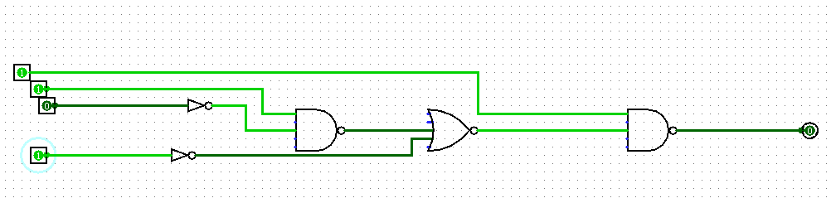As you can see the for the input values **A=1, B=1, C=0, D=1** we have got the output to be 0 through the Logisim program which confirms the truth table above for the circuit to be correct.

**Conclusion:**

The values were produced by passing all possible inputs through certain gates, each of which produces an output, which becomes an input for the next gate, that will help us to get the final output result. When the inputs are given **A=1,B=1,C=0,D=1** this is only when the output is given 0 which can be proven by the Logisim Program.